February 2023

The Illinois Skeet Shooting Association Proudly Announces….

The 2023 Illinois All-State Team

Congratulations!!!

Your shooting accomplishments in the year 2022 have earned you a place on the 2023 Illinois All-State Team.

Congratulations once again on your fantastic shooting last year and good luck in the upcoming season. Here’s to two at low eight each round!!

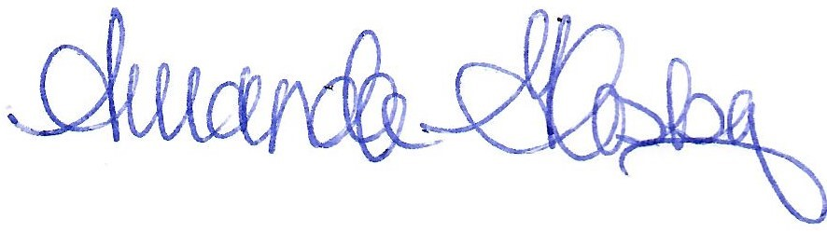
Sincerely,

Amanda Glasby
Secretary/Treasurer
Illinois Skeet Shooting Association

